**Github in R**

Could simply open the R project document if most current version already on my desktop (99% sure this is correct). Or, if I want to work from whatever version is online, start by accessing the project from file.

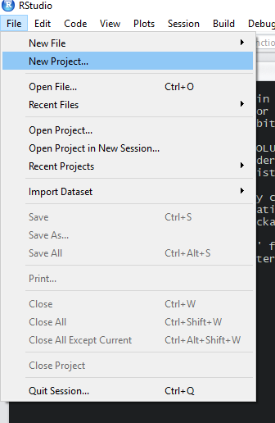

Select version control to bring up GitHub.

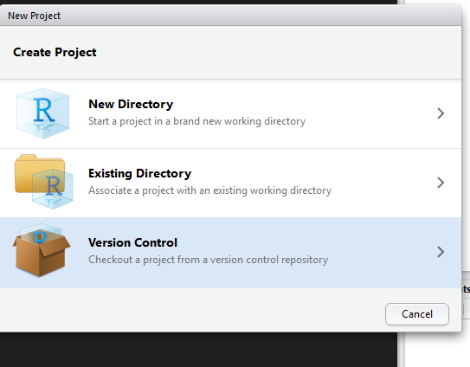

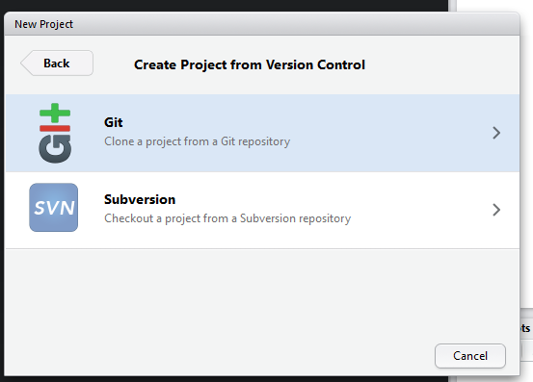

Paste the repository url into the top box, project directory should auto populate, choose the folder where I want the new directory to be stored (won’t work if there is already a director saved there). Check the box to open as a new session, usually just good practice to use.

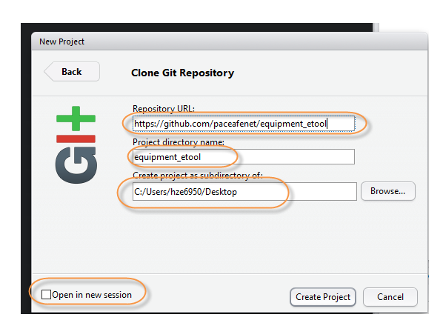

Now there will be all the files available in this directory. Relative folder paths should work. Double click the file to open it in project.

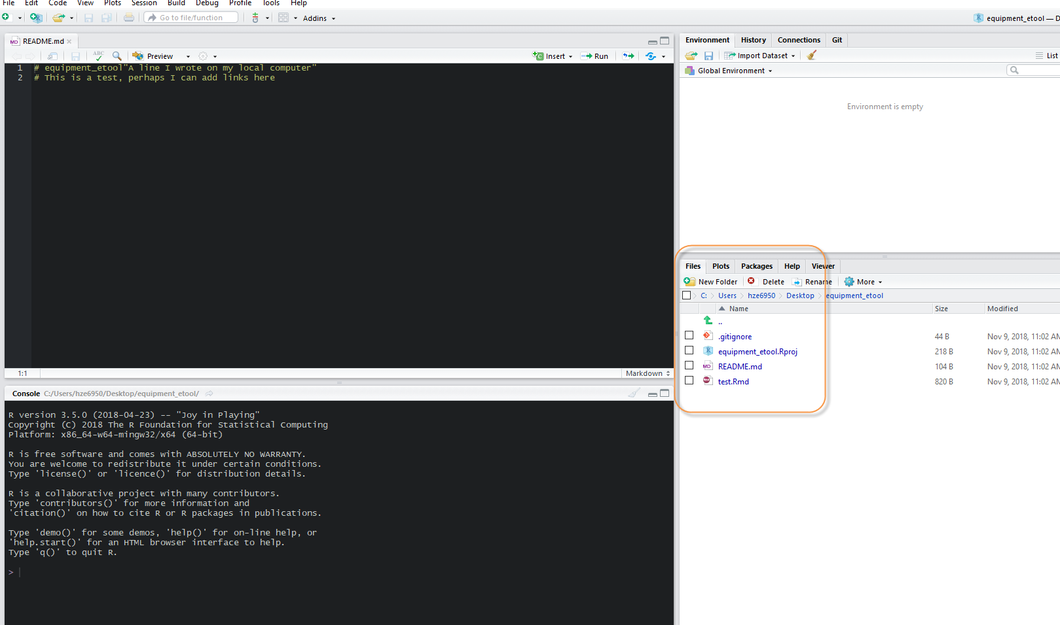

There will now be a Git tab in the IDE, files will show up in the pane once saved in RStudio.

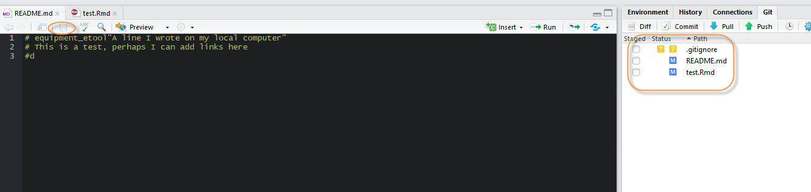

Check the box for files I want to commit to the directory.

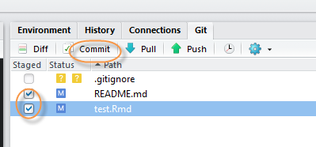

Add a note in the commit section, should be short (I forget the limits). Put the date and if I made the changes from a local computer.

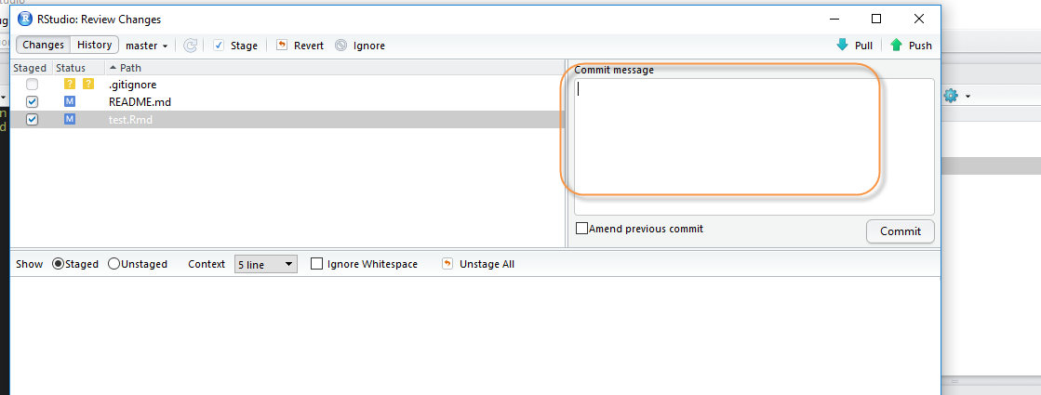

‘Push’ to repo, should ask where I want to push it to and for my credentials.

